For all of the following scenarios, even if you test negative for COVID-19 or feel healthy, you should stay home (quarantine) since symptoms may appear 2 to 14 days after exposure to the virus.
See scenarios below to determine when you can end quarantine and be around others.

Scenario 1: Close contact with someone who has COVID-19—will not have further close contact
- I had close contact with someone who has COVID-19 and will not have further contact or interactions with the person while they are sick (e.g., co-worker, neighbor, or friend).
- Your last day of quarantine is 14 days from the date you had close contact.
Date of last close contact with person who has COVID-19 + 14 days= end of quarantine
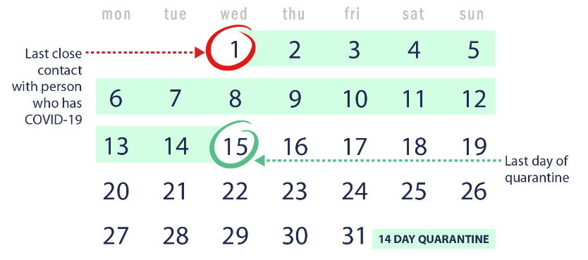
Please note if your quarantine starts at noon on day 1, then it would end at noon on the last day.

Scenario 2: Close contact with someone who has COVID-19—live with the person but can avoid further close contact
- I live with someone who has COVID-19 (e.g., roommate, partner, family member), and that person has isolated by staying in a separate bedroom. I have had no close contact with the person since they isolated.
- Your last day of quarantine is 14 days from when the person with COVID-19 began home isolation
Date person with COVID-19 began home isolation + 14 days = end of quarantine
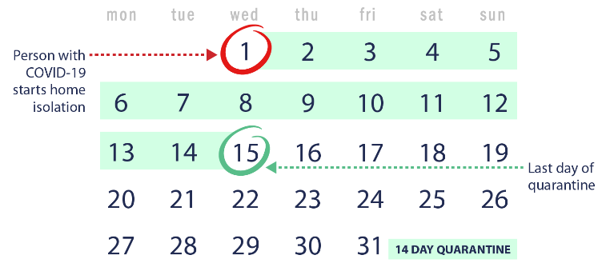
Please note if your quarantine starts at noon on day 1, then it would end at noon on the last day.

Scenario 3. Under quarantine and had additional close contact with someone who has COVID-19
- I live with someone who has COVID-19 and started my 14-day quarantine period because we had close contact. What if I ended up having close contact with the person who is sick during my quarantine? What if another household member gets sick with COVID-19? Do I need to restart my quarantine?
  - Yes. You will have to restart your quarantine from the last day you had close contact with anyone in your house who has COVID-19. Any time a new household member gets sick with COVID-19 and you had close contact, you will need to restart your quarantine.
Date of additional close contact with person who has COVID-19 + 14 days = end of quarantine
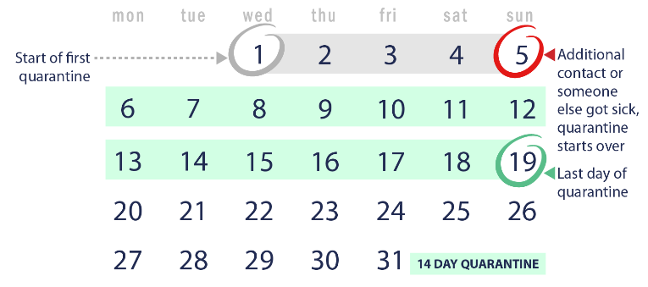
Please note if your quarantine starts at noon on day 1, then it would end at noon on the last day.

Scenario 4: Live with someone who has COVID-19 and cannot avoid continued close contact
- I live in a household where I cannot avoid close contact with the person who has COVID-19. I am providing direct care to the person who is sick, don’t have a separate bedroom to isolate the person who is sick, or live in close quarters where I am unable to keep a physical distance of 6 feet.
- You should avoid contact with others outside the home while the person is sick, and quarantine for 14 days after the person who has COVID-19 meets the criteria to end home isolation.
Date the person with COVID-19 ends home isolation + 14 days = end of quarantine
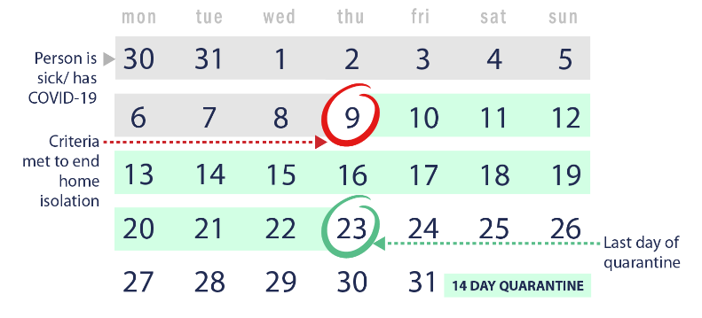
Please note if your quarantine starts at noon on day 1, then it would end at noon on the last day.

